Come and Enjoy Traditional Christmas!
2014 Sliva Family Christmas Concert

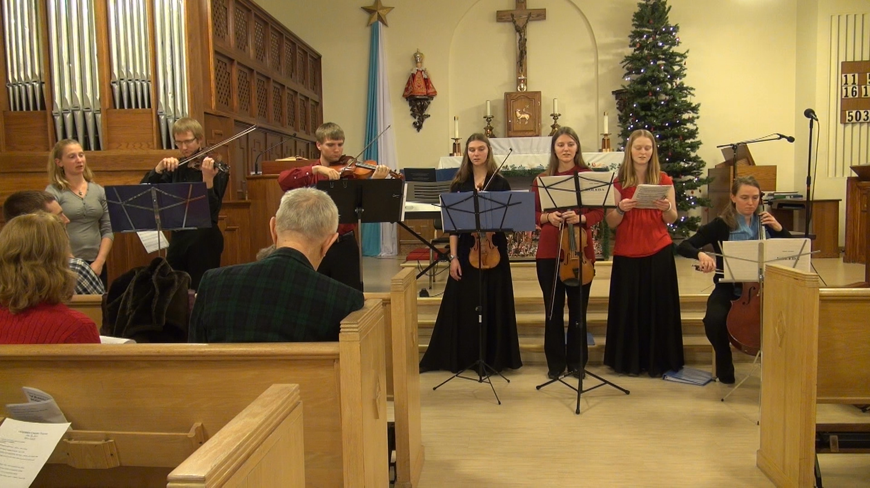

Besides Christmas music and carols, this year’s program includes This Christmastide from Donald Fraser with harp soloist Abby Sliva and Caprice No. 13 by Paganini and Bach’s Allegro from Sonata No. 2 in a minor.

Saturday, Dec 27, 2014 at 4 PM at Czech Catholic Mission of Saints Cyril and Methodius, 9415 Rochester Ave, Brookfield, 60513, IL

http://www.psliva.com/concerts/ http://www.youtube.com/vsliva

Admission: donations appreciated
Refreshments will be served immediately after the concert
December 26, 2014
Program may change

